|  |
| --- |
|  |
| jMPDC |
| UI Specification |
|  |
| **Philip Rodning** |
| **3/18/2014** |

Table of Contents

[To update the table of contents, right click the message below and select Update Field (F9 on PC, ⌥⌘U on Mac).]

1. Pages 3

1.1. Page Tree 3

1.2. Home 4

1.2.1. User Interface 4

1.2.2. Widget Table 4

1.3. Library Panel 6

1.3.1. User Interface 6

1.3.2. Widget Table 6

1. Pages
   1. Page Tree

Home  
 Library Panel

* 1. Home

Layout Manager is GridBagLayout

total grid size:

width = 4

height = 5

* + 1. User Interface

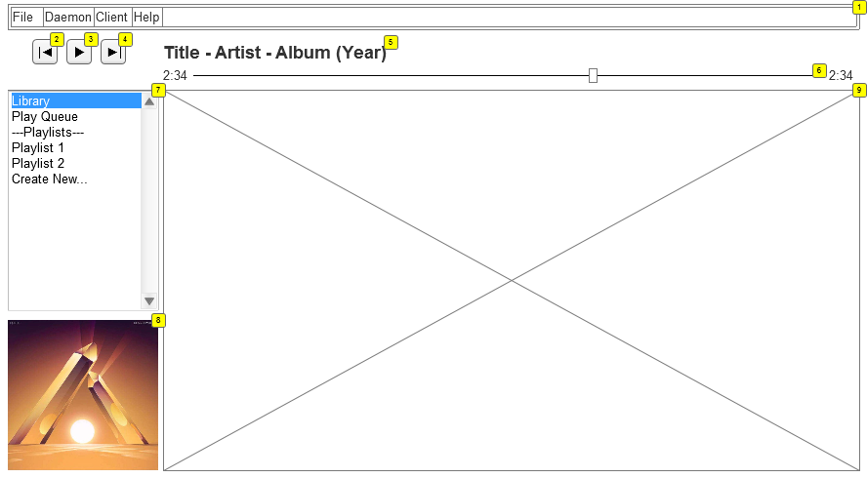

* + 1. Widget Table

|  |  |  |  |  |  |  |  |
| --- | --- | --- | --- | --- | --- | --- | --- |
| Footnote | Label | Control | Initialization | Response | gridposition | Weight | gridsize |
| 1 | MainMenu | Menu |  | fixme | x = 0, y = 0 | x = 1, y = 0 | x = 4, y = 1 |
| 2 | Previous Track | Button |  | Send the previous track command to the server | x = 0, y = 1 | x = 0, y = 0 | x = 1, y = 2 |
| 3 | Play/Pause | Button | Initialize as either a play or pause button: Play if there is no music currently playing, or pause if there is. | Sends the Play/Pause command to the server. Switches between a play button and a pause button based on whether there is currently music playing. | x = 1, y = 1 | x = 0, y = 0 | x = 1, y = 2 |
| 4 | Next Track | Button |  | Sends the next track command to the server | x = 2, y = 1 | x = 0, y = 0 | x = 1, y = 2 |
| 5 | Title | Label |  |  | x = 3, y = 1 | x = 1, y = 0 | x = 1, y = 1 |
| 6 | Seek | Slider | Get the current seek position from the server and sync it | On change, send new seek time to server. | x = 3, y = 2 | x = 1, y = 0 | x = 1, y = 1 |
| 7 | Main Panel Selection | Combobox | Initialize with the following options:  Library Play Queue ---Playlists---  Following the ---Playlists--- line, show a list of all available playlists plus a line called "Create New..." | On selection of either Library or Play Queue, show their respective panel in the main panel.  ---Playlists--- is a divider and does nothing  Any of the playlists should show the playlist editor in the main panel | x = 0, y = 3 | x = 0.2, y = 1 | x = 1, y = 1 |
| 8 | Album Art | Image | Initialize to the album art of the current playing song. If no song is playing, initialize blank. | Allow a method call to update the image with the album art of a new song when it begins playing. | x = 0, y = 4 | x = 0.2, y = 0 | x = 1, y = 1 |
| 9 |  | JPanel | Load the JPanel associated with the selection in the Main Panel Selection |  | x = 3, y = 3 | x = 0.8, y = 1 | x = 1, y = 2 |

* 1. Library Panel
     1. User Interface

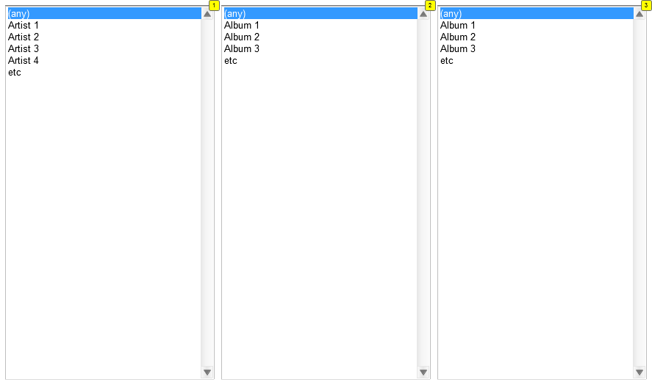

* + 1. Widget Table

|  |  |  |  |  |  |  |  |
| --- | --- | --- | --- | --- | --- | --- | --- |
| Footnote | Label | Control | Initialization | Response | gridposition | Weight | gridsize |
| 1 | Artist Selection | Combo Box | Show "(any)" followed by every artist found in the database | On change, call a method of the album and song selectors to update them, filtering to only show selections corresponding to the selected artist. | x = 0, y = 0 | x = 0.7, y = 1 | x = 1, y = 1 |
| 2 | Album Selection | Combo Box | Show "(any)" followed by every album found in the database. | On change, call a method of the song selector to update it, filtering to only show selections corresponding to the selected album. | x = 0, y = 1 | x = 0.7, y = 1 | x = 1, y = 1 |
| 3 | Song Selection | Combo Box | Show "(any)" followed by every song found in the database. | On change, fixme | x = 0, y = 1 | x = 0.7, y = 1 | x = 1, y = 1 |